MATH 3042 – R Studio Practice Problems

Here are some questions like ones you may see in the R Studio part of your midterm. Work through all of these from start to finish – mostly to make sure you have all the necessary packages installed and enabled and that you are not getting any weird errors. Note that this practice worksheet is longer than the R Studio component of your midterm will be.

1. In this question, you are going to be working with the **leuk** dataset, which is part of the **MASS** package. Load the dataset and take a minute or two to read about it. Also be sure to load the **dplyr** and **mosaic** packages.
   1. Give a command that creates a table called **AGNegative** of patients whose AG test result was “absent”.
      1. AGNegative=filter(leuk, leuk$ag == "absent")
      2. table(AGNegative)
   2. What is the mean white blood cell count for patients whose AG test result was “absent”? Provide the command and its output.
      1. mean(AGNegative$wbc) 🡪 [1] 29262.5
   3. Create a histogram of survival times for patients whose AG test result was “absent”. Give the command and paste your histogram into your Word document.
      1. hist(AGNegative$time)
      2. 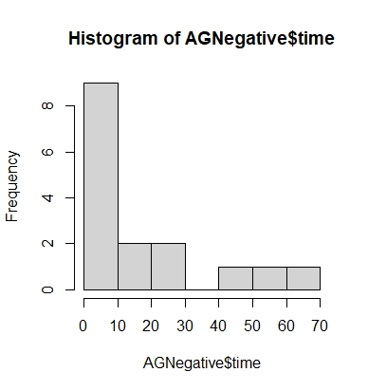
2. This question uses the data from the **crabs** dataframe, which is part of the library **MASS**. Load the dataset and take a minute or two to read about it. Also be sure to load the **mosaic** package.
   1. Find the median frontal lobe size of the crabs. Include both your command(s) and your output.
      1. median(crabs$FL) 🡪 [1] 15.55
   2. Create a dataset consisting of the male crabs. Include only your command(s).
      1. maleCrabs=filter(crabs, crabs$sex == "M")
   3. What proportion of the male crabs have frontal lobes that are larger than the median frontal lobe size you found in part a)? Include both your command(s) and your output.
      1. mean(maleCrabs$FL > median(crabs$FL)) 🡪 [1] 0.51
      2. OR
      3. largeLobes=filter(maleCrabs, maleCrabs$FL > median(crabs$FL))
      4. nrow(largeLobes) 🡪 [1] 51
      5. 51 male crabs / 51% (maleCrabs = 100) have larger frontal lobes than the median found in part a.
   4. Create side by side boxplots of the male crabs’ frontal lobe size, grouped by species. Give your boxplots descriptive titles and axis labels. Include both your command(s) and your boxplot.
      1. bwplot(FL~sp, data = maleCrabs, xlab = "Crab Species (Blue and Orange)", ylab = "Frontal Lobe size (mm)", main = "Male Crab Species Frontal Lobe Size")
      2. 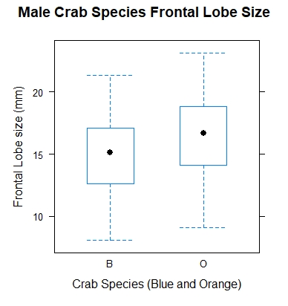
3. A standard deck of cards contains 52 cards. There are 13 ranks of card (ace, 2,3,…,10,J,Q,K), and 12 cards (the 4 jacks, 4 queens, and 4 kings) are “face cards”.
   1. Write a command or a series of commands that simulates 10000 cards **with** replacement, and returns a bar plot that gives the frequency of each rank of cards. Don’t worry about labelling your barplot accurately.
      1. tenThousandDraws=sample(c(Cards), 10000, replace = T)
      2. barplot(table(tenThousandDraws), cex.names = 0.5, las = 2)

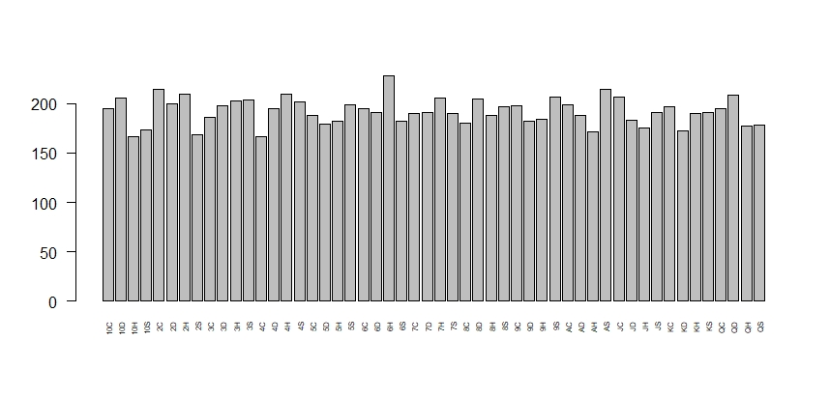

* 1. Write a command or series of commands that simulates selecting 10 cards **without** replacement, and returns the number of face cards. Run your command(s) 10 times and include the output.
     1. tenCards=sample(c(Cards), 10, replace = F)
     2. sum(grepl("J", tenCards))+sum(grepl("Q", tenCards))+sum(grepl("K", tenCards))
     3. x10
     4. 1, 2, …